 HOODY  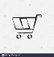 

|  |
| --- |
| Search |



Retail

Whole Sale

Under Menu

|  |
| --- |
| All category |
| Language |
| Location |
| My Orders |
| My Cart |
| My Wishlist |
| My Account |
| My Nonfiction |
| My Query |
| Help Centre |

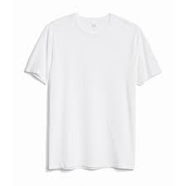

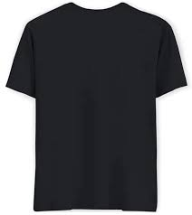  
 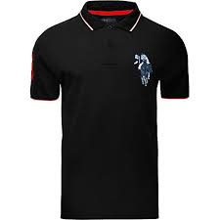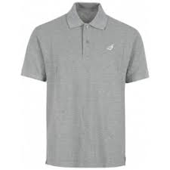

Home Page

  HOODY  

Banner

Free shipping Limit

|  |
| --- |
| Men’s |
| Women’s |
| Couples |
| Folks |
| Create Your Own |

Whole sale page

 

Filters

|  |
| --- |
| Quantity (Should starts with min 30) |
| Size |
| colour |

Description

Size Chart

Men’s page Whole sale